# REST V2 connector – OpenWeather API

Objective:

To get the current weather details for a city using the OpenWeather API and write the details in a flatfile.

OpenWeather is an API that gives the weather details for locations in JSON format. We establish a REST v2 connector to connect to this API.

A REST connection to the OpenWeather API is created.

Goto Connections -> New connection with type: REST V2(Informatica Cloud). Specify the path of the swagger file.

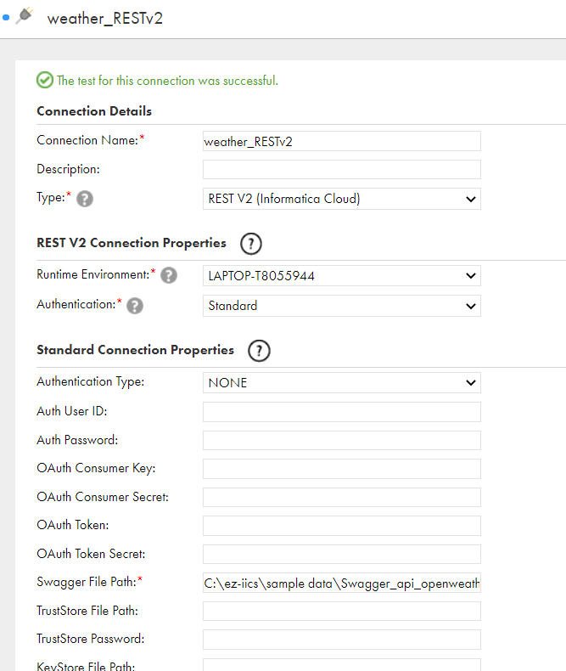

Then I create a mapping with source that uses this REST connection. Select the Operation as ‘Get’ and in the Query Options->Configure – update the message to include the API key and the location required.

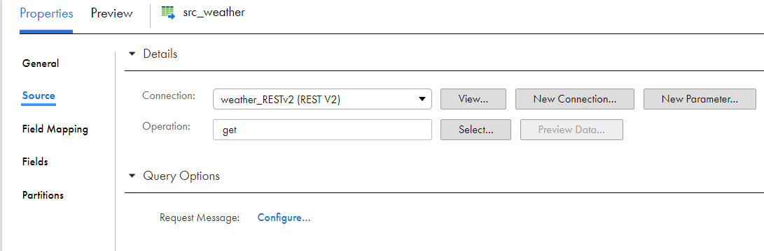

In Field Mapping -> Map all descendants

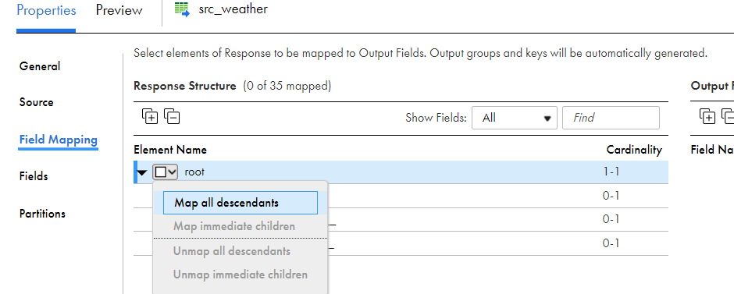Map the source to the target by the ‘Root’.

Target connection – a flat file connection with the filename dynamically generated.

Run the mapping.

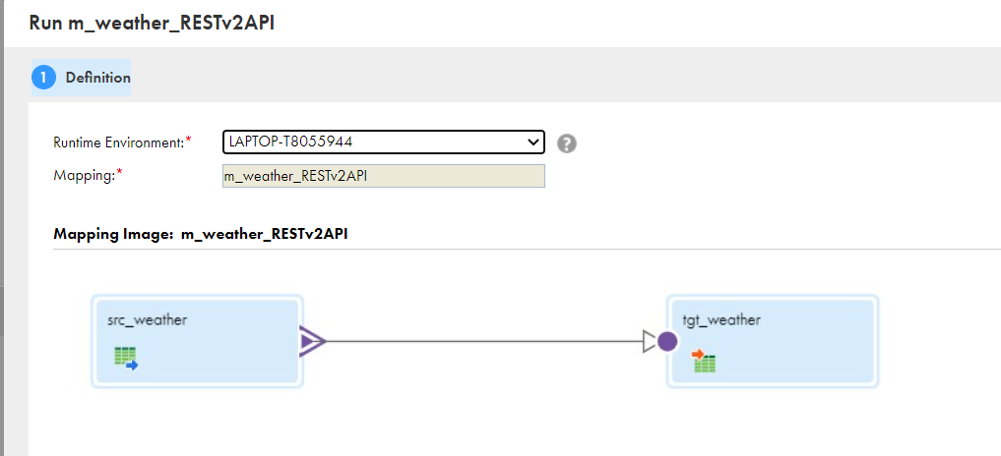

The output file gets generated with all the weather details of the city.